Pfsense Dual WAN & Single LAN Setup

Step :1 Login Pfsense and assign a Interface

Open the web interface using http://192.168.2.1/ then give a username and password for administrator
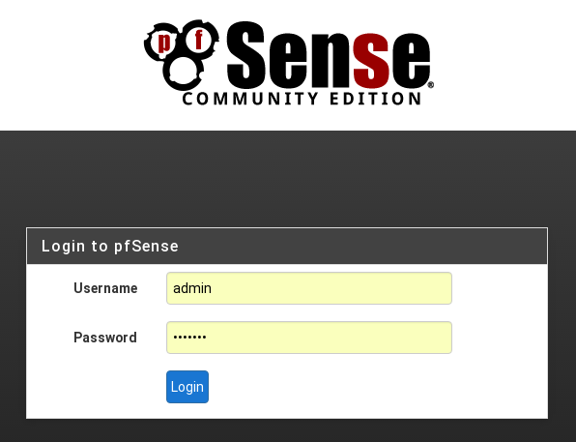

To navigate the pfsense menu opiton interface → choose assign tab, then assign which interface to which networkport for LAN & two WAN.
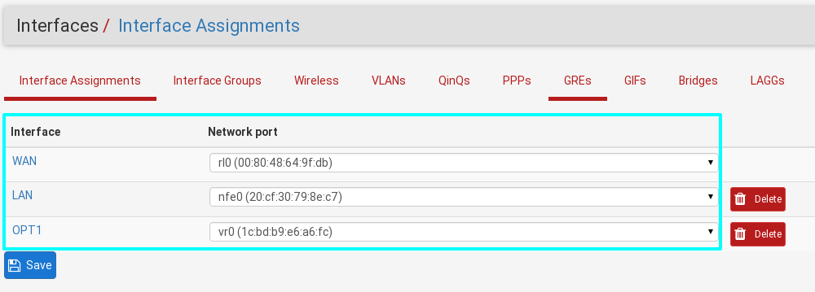

Step :2 Configure pfsense LAN interface

Opon the lan interfce using pfsense web page http://192.168.2.1. set the lan for below picture

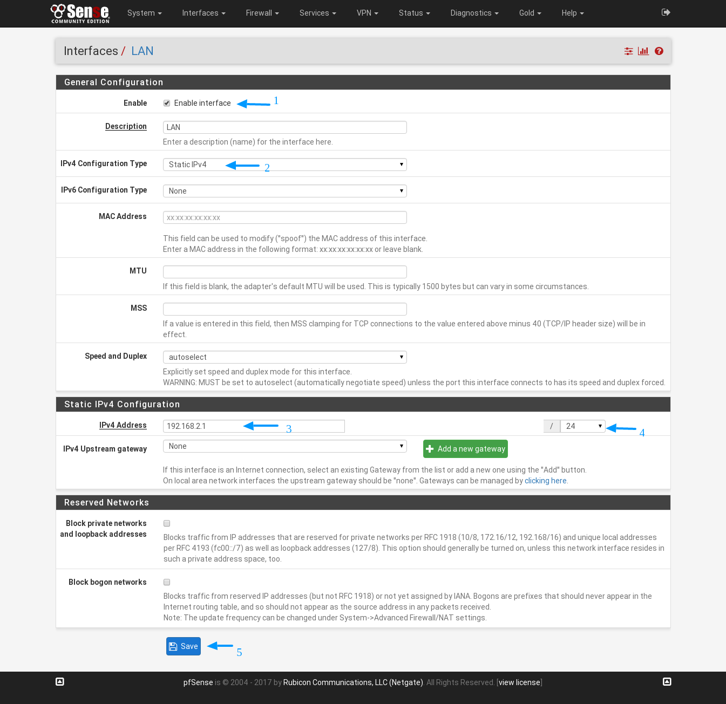
Finally save & apply the changes.

Step :3 Configure pfsense WAN-1 interface

Open the lan interfce using pfsense web page http://192.168.2.1. set the WAN-1 for below picture

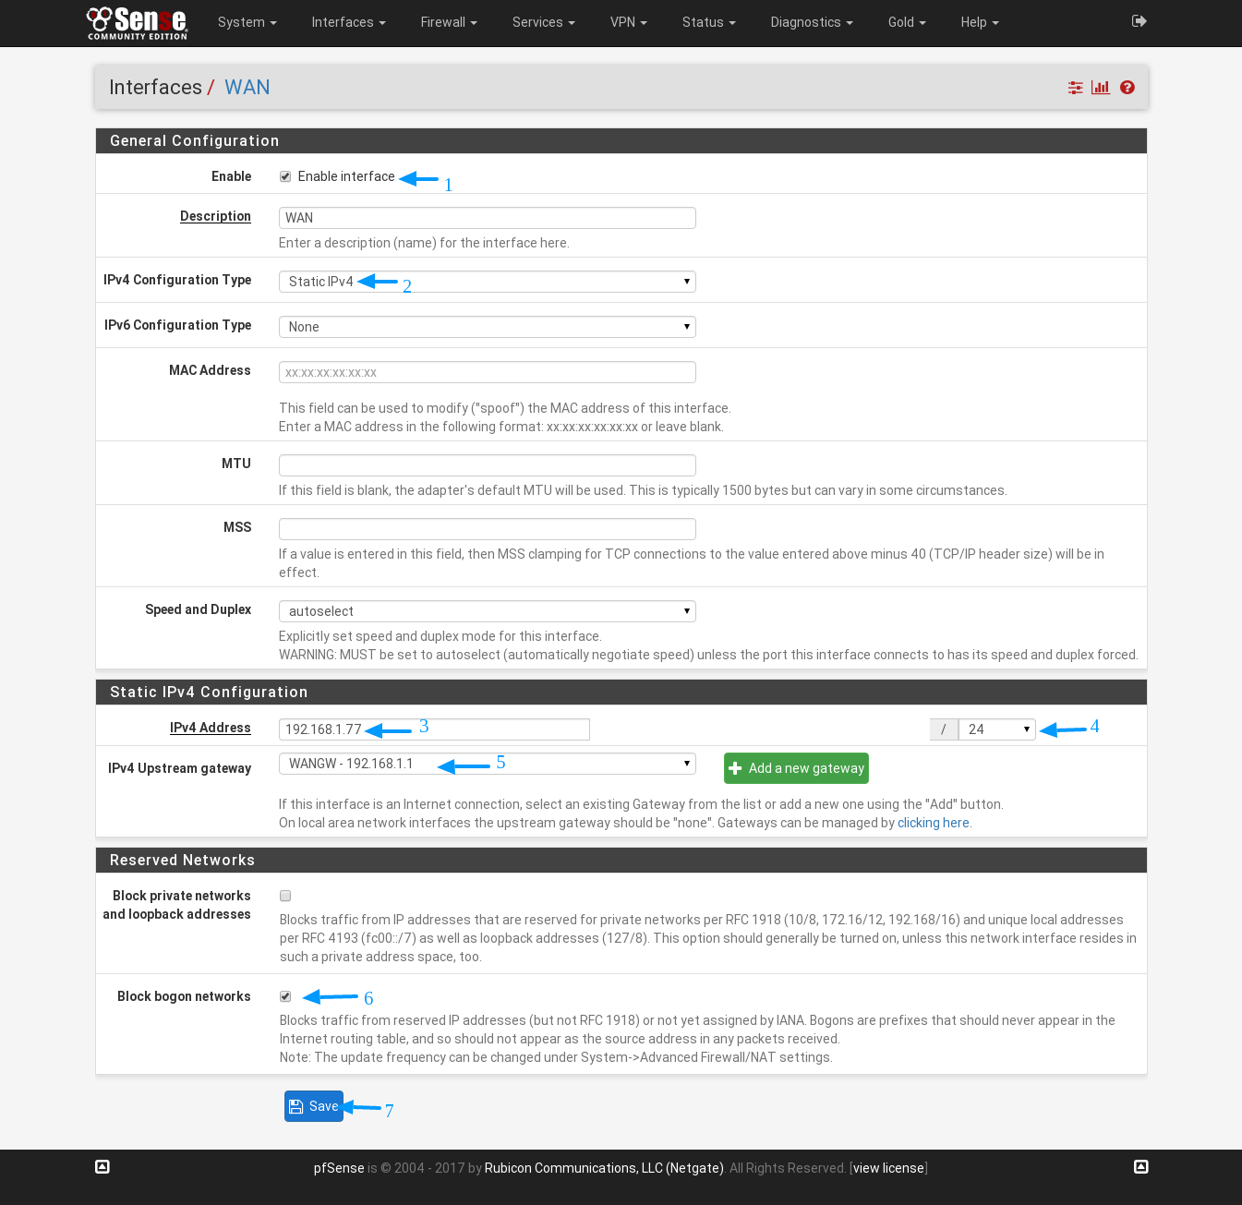
Finally save & apply the changes.

Step :4 Configure pfsense WAN-2 interface

Open the WAN2 interfce using pfsense web page http://192.168.2.1. set the WAN-2 for below picture

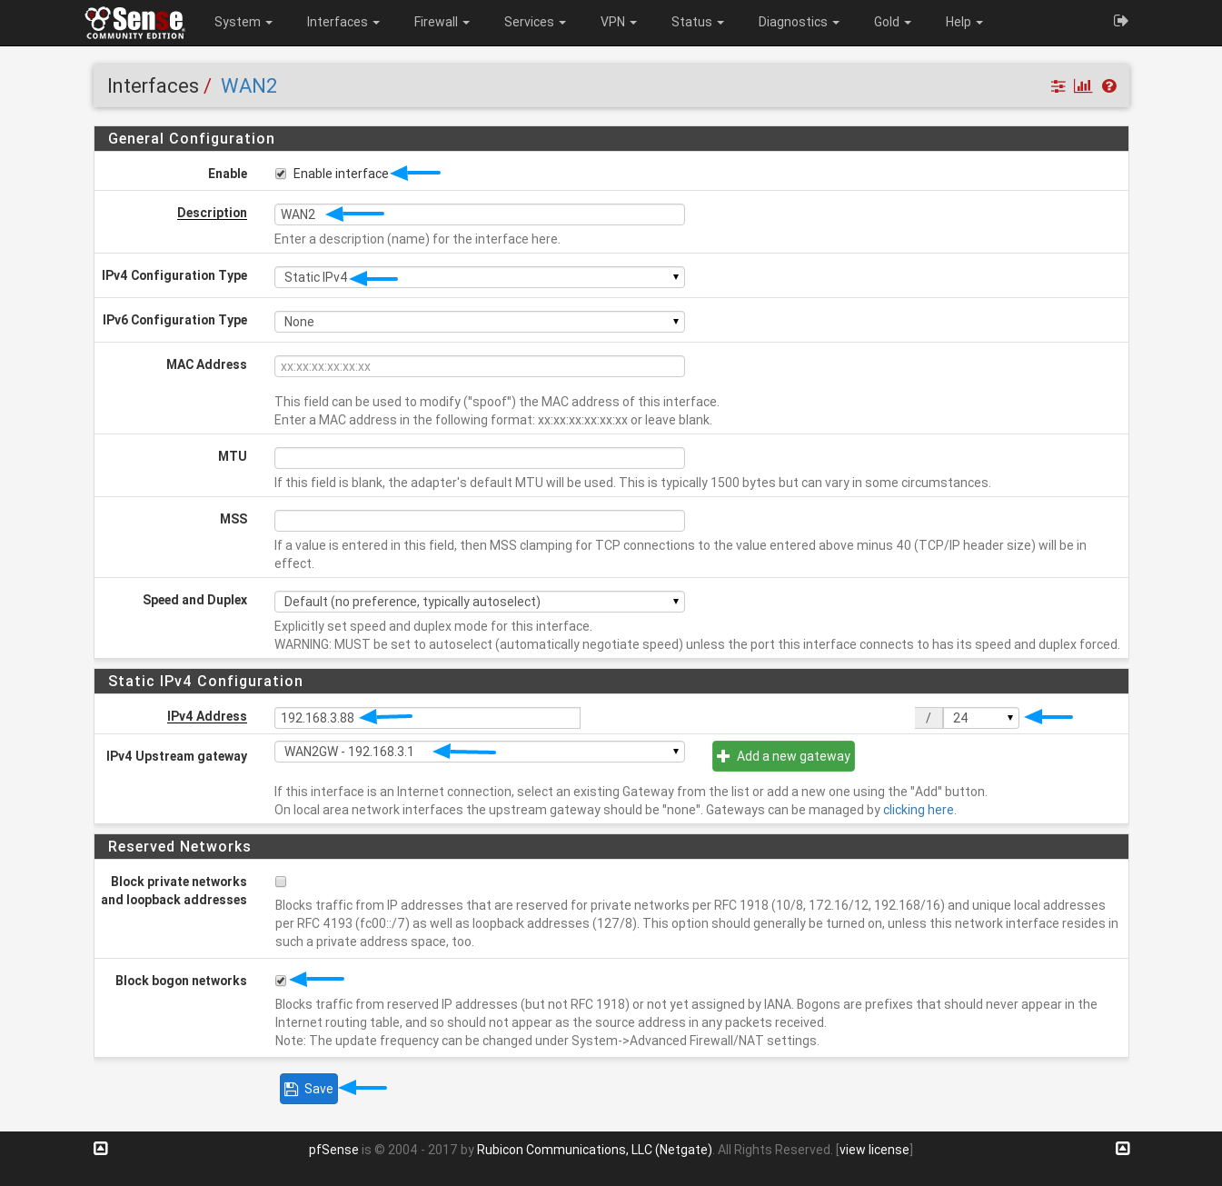

Finally save & apply the changes.

When we have configure the WAN2 interface, it showing error like "IPv4 address 192.168.1.88/32 is being used by or overlaps with: WAN (192.168.1.77/24)".

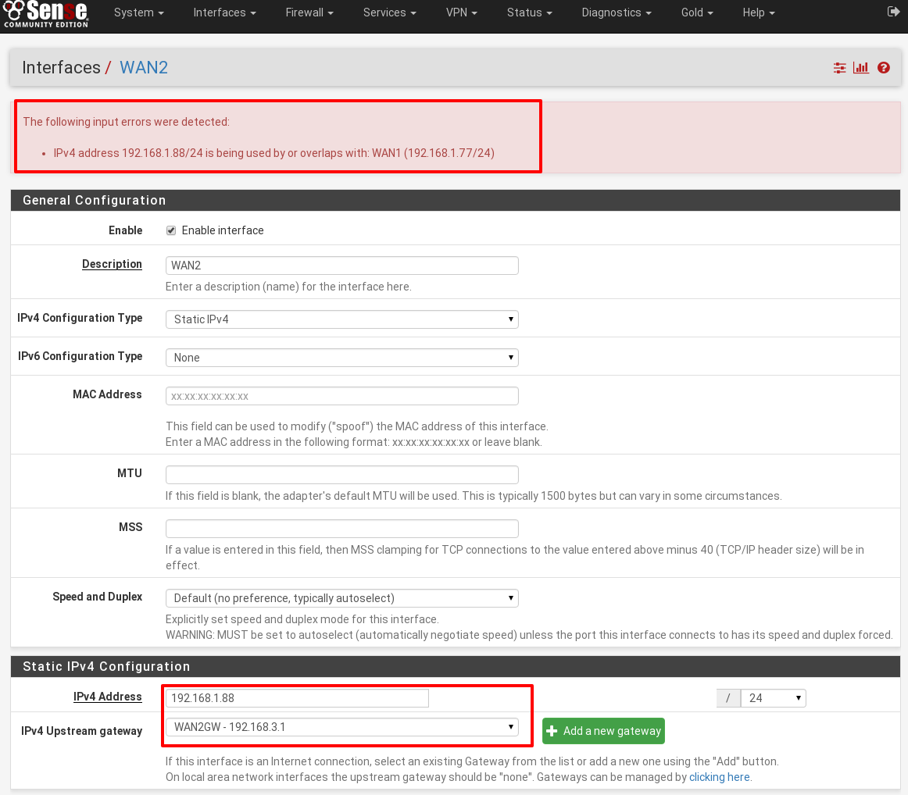

Solution
We need to change IP range's on our LAN at ISP(airtel or ACT) provider. Then only we will configure & Implement the Dual WAN and Single LAN.

